SYSTEM CALLS

What is a System Call?
A system call is a method for a computer program to request a service from the kernel of the operating system on which it is running. A system call is a method of interacting with the operating system via programs. A system call is a request from computer software to an operating system's kernel.

How are system calls made?
When a computer software needs to access the operating system's kernel, it makes a system call. The system call uses an API to expose the operating system's services to user programs. It is the only method to access the kernel system. All programs or processes that require resources for execution must use system calls, as they serve as an interface between the operating system and user programs.
Below are some examples of how a system call varies from a user function.
- A system call function may create and use kernel processes to execute the asynchronous processing.
- A system call has greater authority than a standard subroutine. A system call with kernel-mode privilege executes in the kernel protection domain.
- System calls are not permitted to use shared libraries or any symbols that are not present in the kernel protection domain.
- The code and data for system calls are stored in global kernel memory.

Types of System Calls
There are commonly five types of system calls. These are as follows:
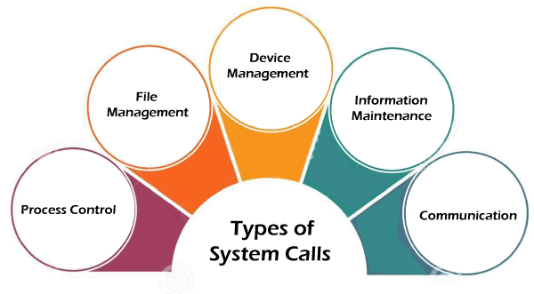
- Process Control
- File Management
- Device Management
- Information Maintenance
- Communication
Now, you will learn about all the different types of system calls one-by-one.

Process Control
Process control is the system call that is used to direct the processes. Some process control examples include creating, load, abort, end, execute, process, terminate the process, etc.

File Management
File management is a system call that is used to handle the files. Some file management examples include creating files, delete files, open, close, read, write, etc.

Device Management
Device management is a system call that is used to deal with devices. Some examples of device management include read, device, write, get device attributes, release device, etc.

Information Maintenance
Information maintenance is a system call that is used to maintain information. There are some examples of information maintenance, including getting system data, set time or date, get time or date, set system data, etc.

Communication
Communication is a system call that is used for communication. There are some examples of communication, including create, delete communication connections, send, receive messages, etc.
Process | Windows | Unix
Process Control | CreateProcess()  ExitProcess()  WaitForSingleObject() | Fork()  Exit()  Wait()
File Manipulation | CreateFile()  ReadFile()  WriteFile()  CloseHandle() | Open()  Read()  Write()  Close()
Device Management | SetConsoleMode()  ReadConsole()  WriteConsole() | Ioctl()  Read()  Write()
Information Maintenance | GetCurrentProcessID()  SetTimer()  Sleep() | Getpid()  Alarm()  Sleep()
Communication | CreatePipe()  CreateFileMapping()  MapViewOfFile() | Pipe()  Shmget()  Mmap()

